William Nunn is your Breckland Councillor and on the next pages you can read what the Council has Achieved in the past year. 22’23
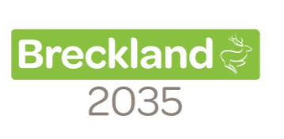

To support our local environment, we have -

- Reduced our output of Carbon Dioxide (CO2) emissions by 437 Tonnes since 19/20
- Invested £850k in LED replacement streetlights.

- Encouraged Developers to reduce their carbon footprint, through our Planning advice.

- Trialled sustainable alternatives to chemical weed treatments.

- Saved energy by installing new LED lighting and pool covers at our leisure centres.

- Increased protection of our natural environment by employing a Forestry Officer.

- Showcased how we can – with others - become NetZero by 2035, by holding an Environment Awareness Month including a NetZero Conference.

- Supported more businesses by providing them with a cost-effective trade waste solution, generating income which can be ploughed back into other Council services.

- Kept our communities cleaner by taking enforcement action against 100 waste offenders for fly tipping or littering.

- Reduced recycling contamination meaning less items to landfill.

- Become more sustainable, by planning a collection scheme for batteries and small electrical items.

- Enabled communities to progress their ‘Green’ agenda by successfully distributing £100k for local schemes.

- Supported greener transport options by awarding a contract for the installation of EV charging points in Swaffham and Watton town centres.

- Helped make Breckland an even greener and beautiful place, by planting 700 trees in Attleborough and Watton to mark Her Majesty’s Platinum Jubilee.

- Showed how we can reduce waste by working with school children in Thetford to recycle and use waste products to grow vegetables and flowers.

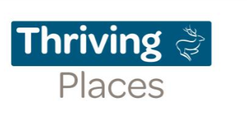

To help our district thrive we have -
- Invested £750K into projects which support our local high streets and enable our 5 Market towns of Dereham, Swaffham, Watton, Thetford and Attleborough and their surrounding areas to thrive.

- Supported economic growth in the district by project managing and funding a new primary substation in Snetterton.
- Encouraged footfall in Thetford to support local businesses by providing free cinema by the town’s riverside.

- Helped businesses bounce back from the COVID Pandemic, by allocating £4.2M of funding.

- Provided a tranquil space for the community and transformed a derelict piece of land by refurbishing the Queen Mothers Garden in Dereham.

- Brought arts and culture to new audiences by helping to bring outside theatre to Thetford Priory.

- Supported over 45 new enterprises and created more than 65 jobs with our successful Start Up Programme

- Secured £1.6m national funding for local projects to boost local skills and training, reduce carbon emissions and support our most vulnerable residents.

- Bid for £1m in national funding to help support rural businesses and communities over the next two years. This funding will be vital in helping us provide new infrastructure and support to help grow our important rural economy.

To inspire our local communities, we have -

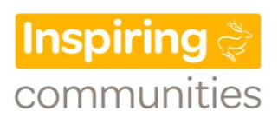
- Helped provide accommodation for our residents by investing over £4.6 million in emergency housing.

- Helped domestic abuse survivors, by supporting the Daisy Programme with £100,000 of funding over 3 years.

- Supported our local communities with the increased cost of living pressures by introducing a local food store and a mobile food bus, providing food at more affordable prices.

- Promoted the importance of Mental Health Well-being by providing our partners in Breckland with Mental Health First Aid training.

- Helped to support community well-being by training over 200 residents to become mental health champions.

- Helped the community recover from the pandemic through our 10-year Future Breckland vision and plan.

- Helped to link residents with support groups by our new Social Prescribers, easing the pressure on the NHS.

- Helped people to stay living in their homes, avoiding admission to care homes, through a new pilot handyperson scheme.

- Made a difference to resident's lives every day by awarding over £120,000 to local community projects.

- Enabled community groups and voluntary organisations to come together and celebrate the Platinum Jubilee, by allocating over £12,000 in grants.

- Supported local students to achieve their potential by launching a £10,000 educational bursary.

- Welcomed almost 100 Ukraines to the district, providing them with temporary homes and recruited native-speaking welfare officers to provide the best possible support to refugees.

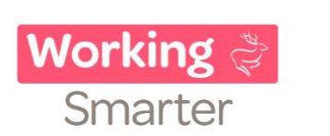

To work smarter, we have -

- Made our website more user friendly and accessible for our customers, particularly for those with a disability. This puts us in the top 10 Councils for website accessibility.

- Helped teams see how they can use data to improve services to residents through our ‘Great to Greater’ sessions.

- Enabled residents to get answers to their queries 24/7 though our new Chatbot, Bobbie and soon, residents will also be able to get answers to queries through Amazon Alexa

- Helped our people provide better services with 16 staff completing apprenticeship courses.

- Made £344,000 in efficiencies this financial year.

- Kept residents informed by sharing a press release at least every 3 days.

- Reached out to more of our community through increasing our use of social media channels.

- Given residents more choice in how they pay for Council services through new on-line forms.

- Won high levels of trust from residents with 79% telling us they felt this way in a recent survey.

- Enabled residents to access advice and support with Customer Contact Services open in Dereham and Thetford

